**Full Name:** Mijail Fausto Blanco Vargas

**Student Number:** 2023012

**Individual Reflective Report**

* **Regarding the individual reflective report, what were your contributions to all aspects of the project, from selecting the dataset to the final presentation and report? Finally, what was your contribution to the creation of a PowerPoint presentation and report?**

My contributions started when we compared datasets and decided to use Emily’s group dataset; analysing indeed all the methodologies applied last semester and we started the coding part applying CRISP-DM methodology which was monitored by me stablishing dates, updating the progress and specially coordinating with Emily our schedules since using Git Hub we can not edit at the same time (See Figure 1,2 and 3).

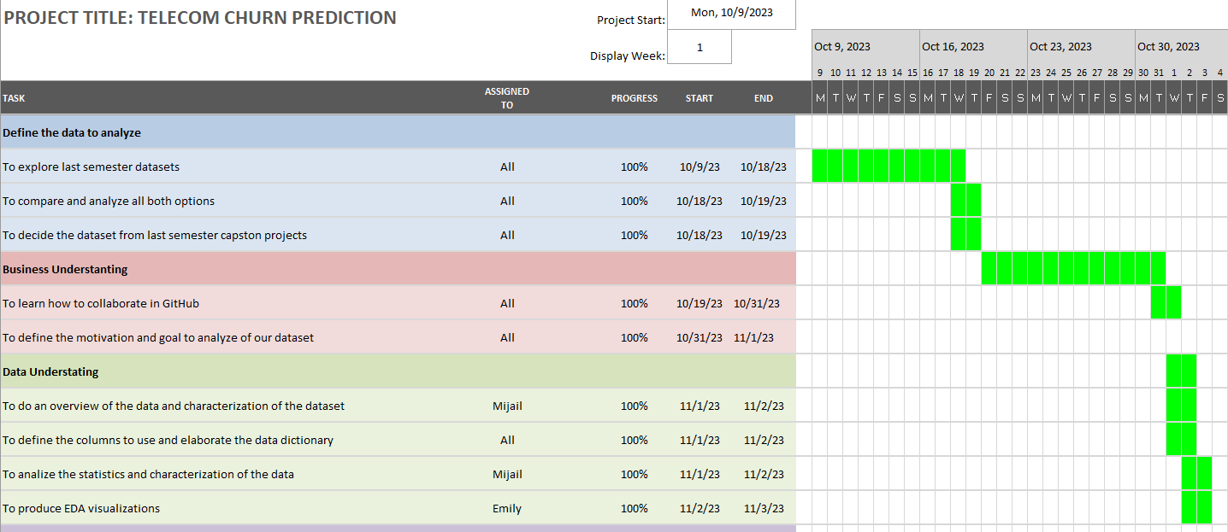

Figure 1: CRIPS-DM Part 1

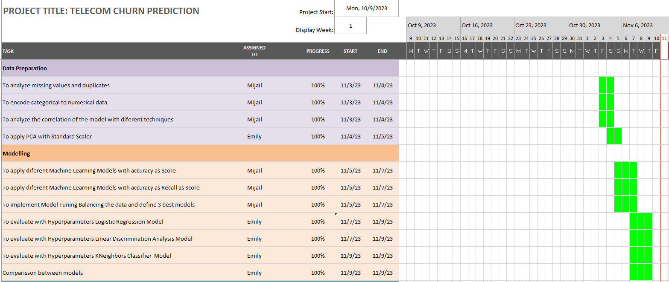

Figure 2: CRIPS-DM Part 2

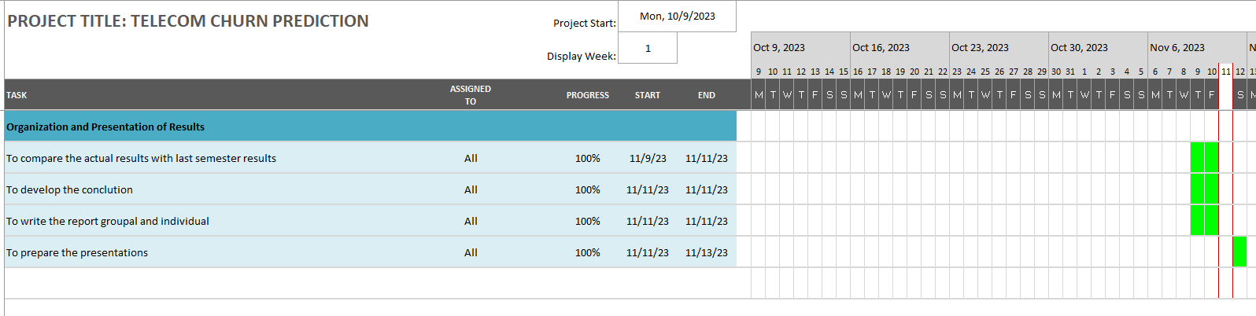

Figure 3: CRIPS-DM Part 3

Then, I analysed the data again with the characterization of the dataset and descriptive statistics, visualizations of the numerical values.

I performed the data cleaning, analysing null values, dropping duplicates and integer encoding analysing indeed and changing the techniques used last semester. In the correlation analysis I implemented ANOVA and chi-squared tests, then I applied model tunning with accuracy and recall as scores and balance the target variable using Model Tuning.

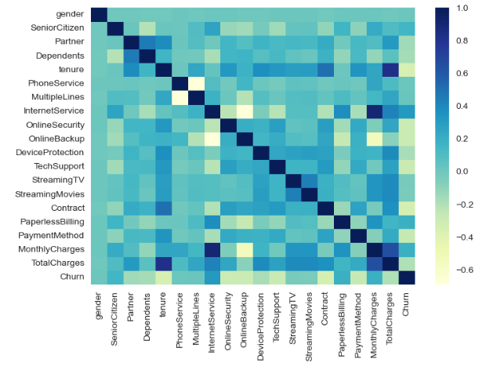

Figure 4: Correlation Matrix



Figure 5: Results of ANOVA Test

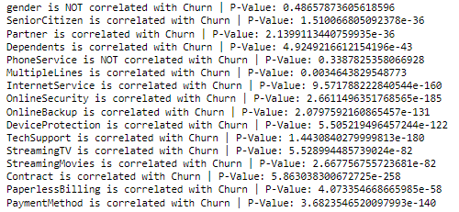

Figure 6: Results of chi-squared Test

Finally with Emily, we wrote the conclusions, comparing last semester model and the improvements done in this new analysis. All the previous was done in Jupiter and also in the report entraining the introduction business understanding and description. All of this was included at the presentations as well.

* **did you work well within the team and were able to leverage each other's strengths? How did you contribute to the communication and were able to communicate effectively? how were you flexible and adapting to changing circumstances?**

Yes, we did a good job helping each other specially when we had mistakes collaborating in knowledge, always talking to edit the project since all was developed using Git Hub and we had to schedule times to edit the files, every time we did a commit, we review each other’s advice giving advise to improve it and we adapted to different circumstances like meetings at CCT college or using Google meet to advance in the project hearing feedback from each other. A challenge for us was to understand how to use Git Hub in a collaborative mode, but after applying different trials, we could do it.

* **How did this project help you develop a deeper understanding of data analytics / AI?**

I learned and developed new techniques about how to improve predictions using new resources like model tunning, analysing indeed not only the accuracy, but also recall focusing on the most important of what we want to predict, exploring the datasets and understanding the statistics and the problem to solve it applying all that we learned in Strategic Thinking classes.

* **How did this project help you develop valuable technical and collaboration skills that can be applied in future projects?**

In any job, it is valuable to learn to work in teams helping each other, listening advises, looking for new techniques because it is very important for overcoming obstacles and not always we are going to know everything, but looking for different methods and understanding why is the technical part that is helpful for overcoming challenges.